SOLUTION FIT TEMPLATE

**PROJECT : EARLY PREDICTION OF CHRONIC KIDNEY DISEASE USING MACHINE LEARNING TEAM ID**: PNT2022TMID23120

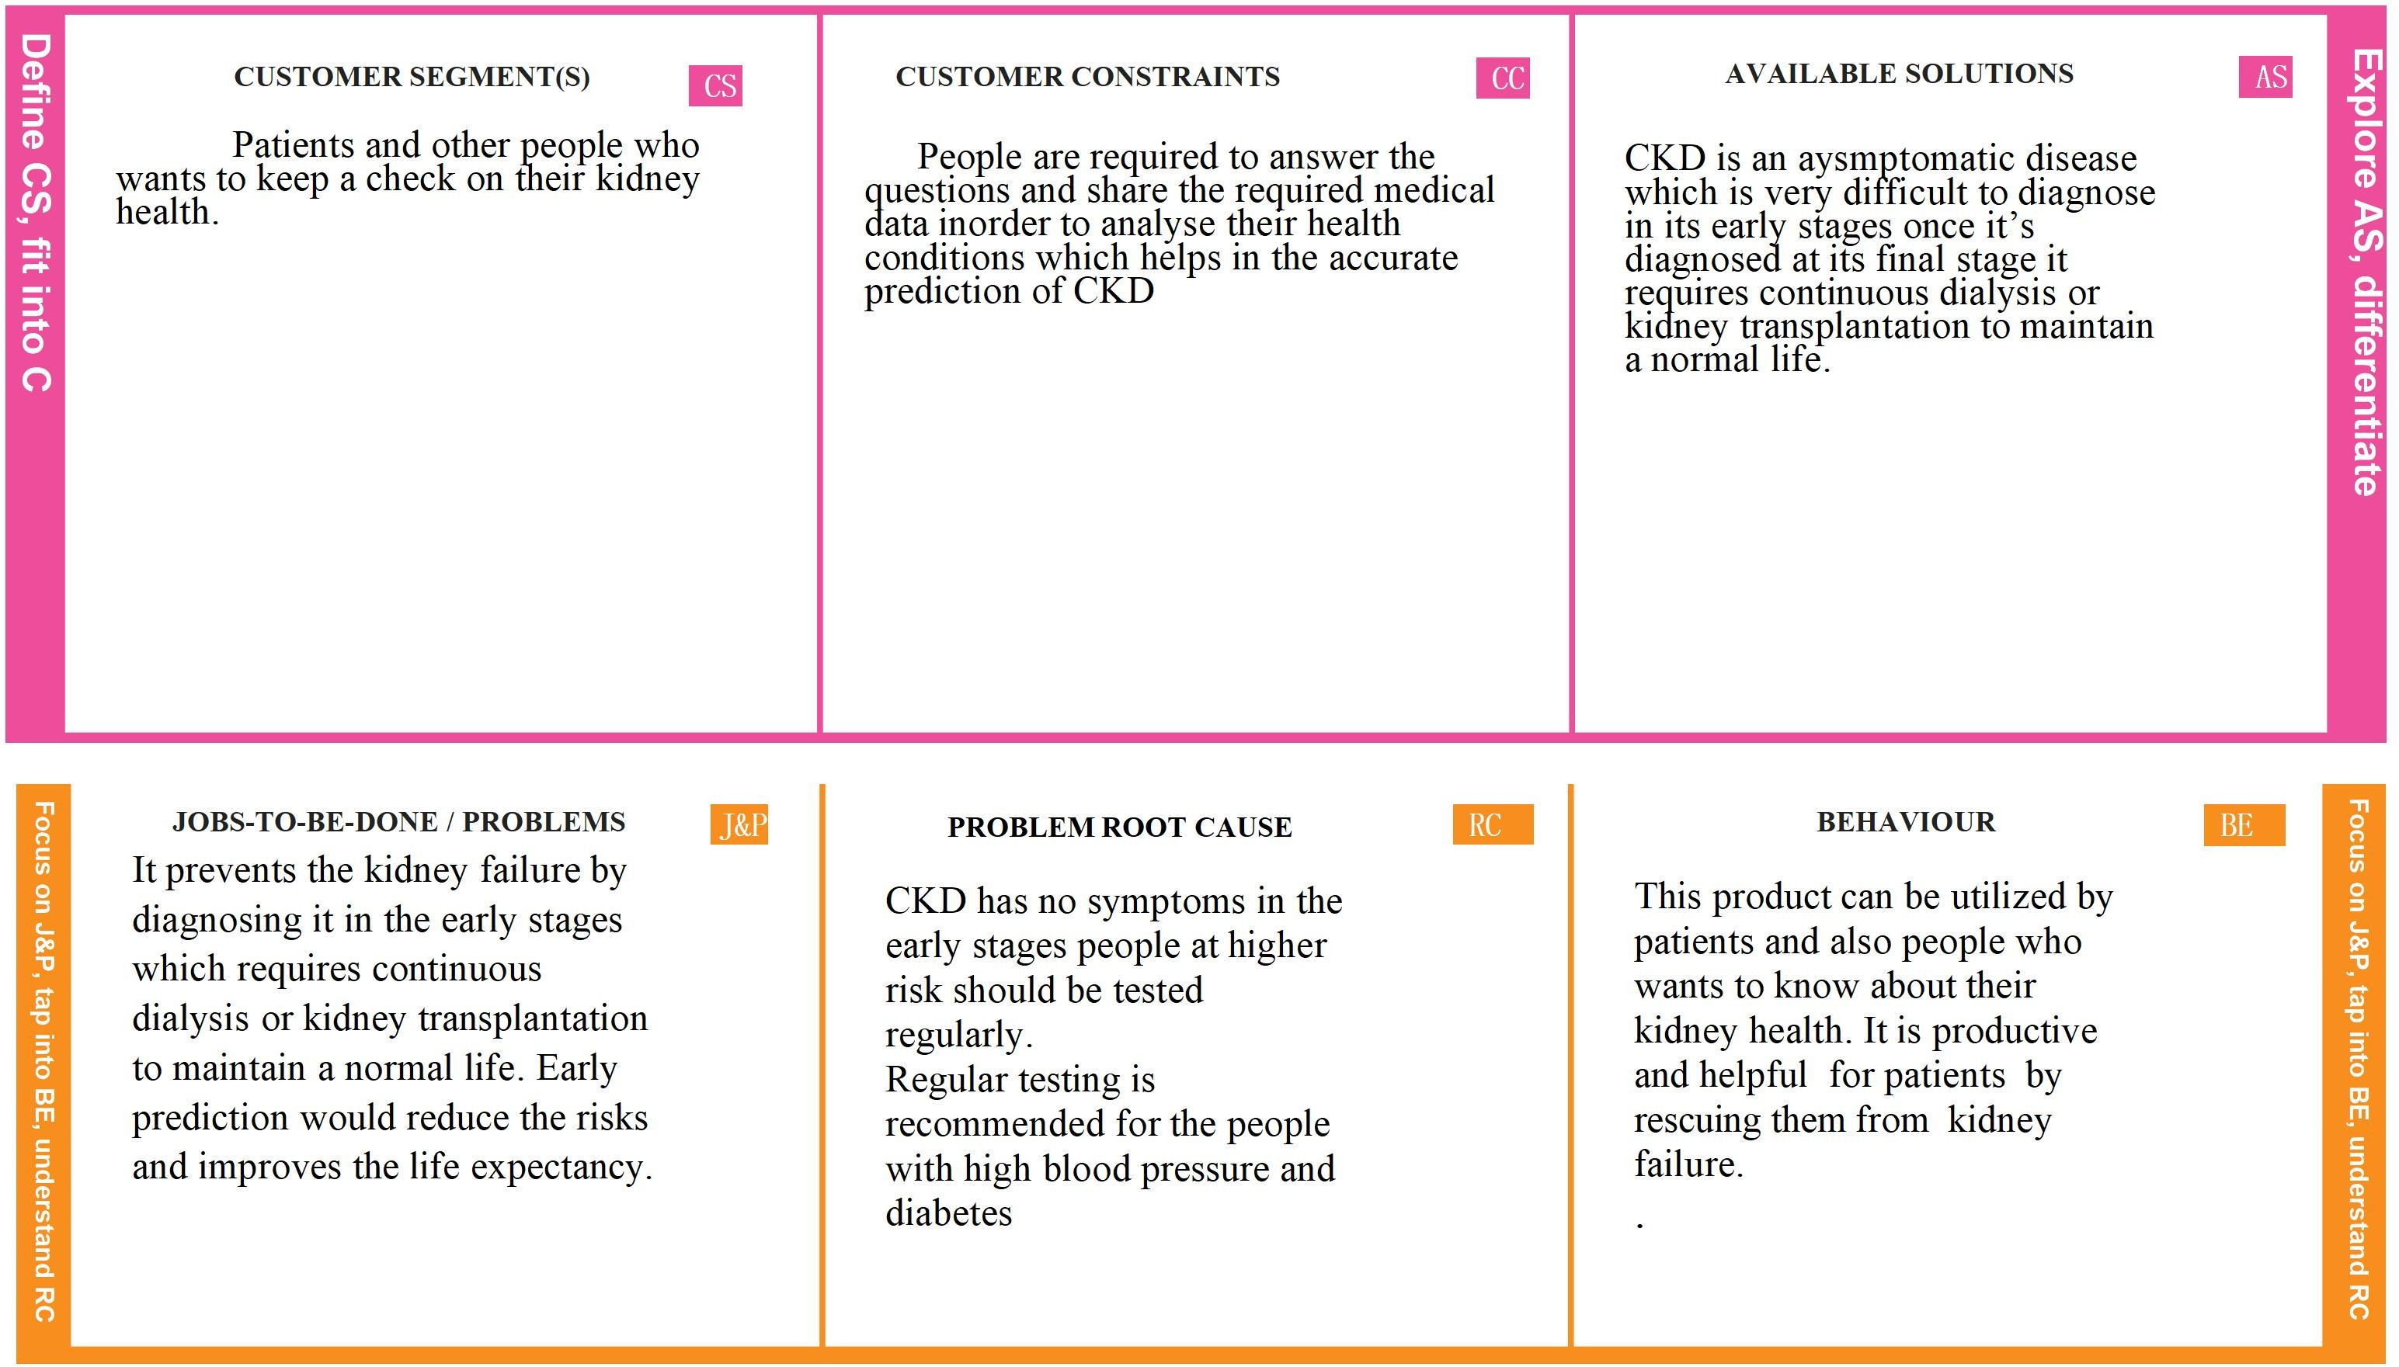

|  |  |  |  |  |
| --- | --- | --- | --- | --- |
|  | **TRIGGERS TR** | **YOUR SOLUTION SL** | **CHANNELS OF BEHAVIOUR CH**  **ONLINE**  To execute this technique we need to develop a Web Application which helps in early prediction of the disease by using various data given by the people |  |
| **I**  **d e n ti f y**  **S**  **tr o n g** | **BEFORE**: CKD cannot be diagnosed at early stages which would decrease the life expectancy of the patients.  **AFTER**: A prediction algorithm is designed to predict Chronic Kidney Disorders at an early stage. | To provide a prediction algorithm to predict Chronic Kidney Disorders at an early stage. The dataset shows input parameters collected from the CKD patients and the models are trained and validated for the given input parameters. | **I**  **d e n ti f y**  **S**  **tr o n g** |
| **T R**  **& E** |  |  | **T R**  **& E** |